##$$kkProjection Method (Panozzo (1984), modified)

In an image of a grain fabric (thin section or polished surface), single grains are digitised as closed polygons. These polygons are rotated around 180°. During this rotation the sum of the lengths of the projections of grain boundaries on a reference line for each increment of rotation. (ΣP[α]) are measured. (Panozzo, 1984). ΣP[α]_{max} is the long axis of sumarized strain ellipse. The corresponding angle Θ is the plunge of the ellipse The ratio ΣP[α]_{max} / ΣP[α]_{min} is the ellipticity (R) of the fabric (Fig. 1).

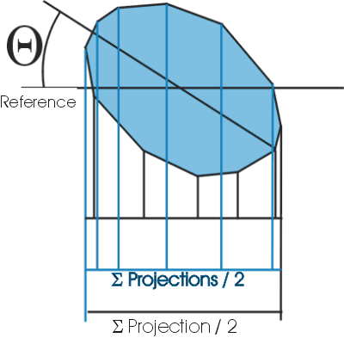
Fig. 1

The evaluation of the data can be done in three diagrams:
1.) Projection / Rotation angle
2.) Form analysis
3.) summarized strain-ellipse
##$$kk>>Projektion length vs Rotation Angle

Method of the strain-analysis with the projection method (Panozzo, 1984).
The lengths of the projections of polygon borders on a reference line are calculated for the increments of a rotation around 180°. They are plotted versus the rotation angle.

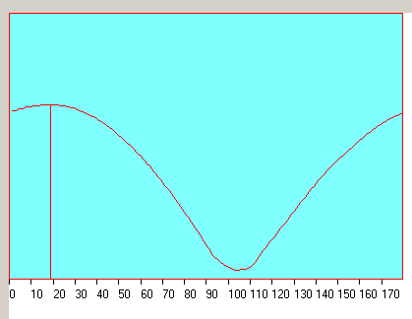
Fig. 1

This relation is defined by a sinus-graph (Fig. 1). The ratio ΣP(α)_{max} / ΣP(α)_{min} (P = Projection). is the ellipticity of the resulting strain ellipse. The angle which belongs to ΣP(α)_{max} is the plunge (Θ) of the ellipse towards the reference line.

##$$kk>>Form Analysis

The form analysis is part of the strain analysis with the projection method. It shows the distribution of projection directions. This distribution is plotted as a rose diagram (Fig. 1).

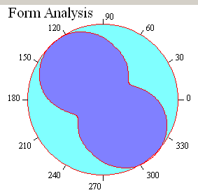
Fig. 1
##$$kk>>Sumarised Strain-Ellipse

The sumarised strain ellipse is part of the strain analysis with the projection method. It is an ellipse with the axes of maximum (ΣP(α)_{max} ) and minimum (ΣP(α)_{min}) projection lengths ( see projections length vs rotation angle, Fig.1).

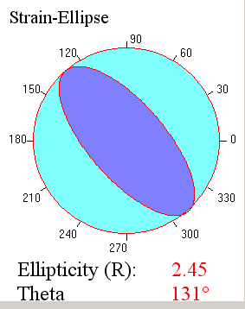
Fig. 1

# Projektionsmethode
$ Projektionsmethode
k Projection method
# ProjektionRotation
$ ProjektionRotation
k Projection/rotation
> Hilfe1
# Formanalyse
$ Formanalyse
k form analysis
> Hilfe1
# summierteStrainEllipse
$ summierteStrainEllipse
k sumarised strain-ellipse
> Hilfe1

